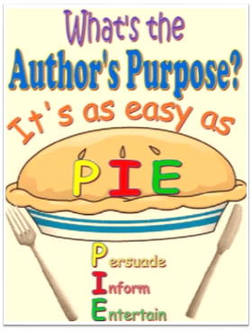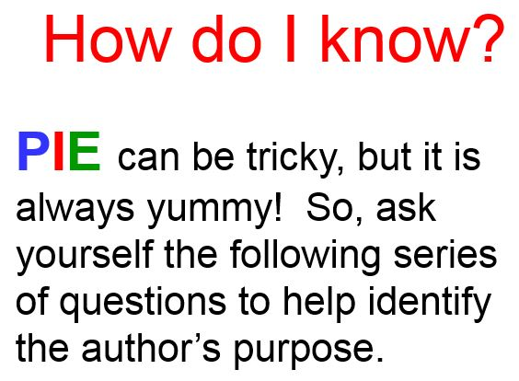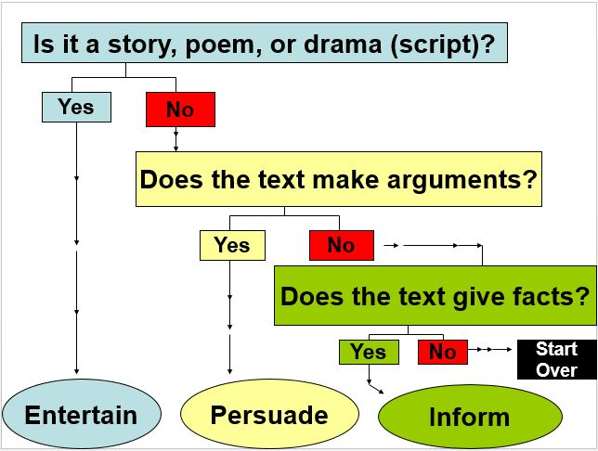

All authors write with one of three main purposes in mind:
Persuade – The author is trying to get you to feel a certain way. It attempts to influence the reader and usually makes an argument. Examples; political speeches, advertisements, a cover letter to a resume, an essay urging readers to recycle.
Inform – The author is giving facts, directions, or information. It is often called an expository writing that shows or explains facts. Examples; biography, news reports, a note to a friend, an essay, scripts for documentaries.
Entertain – The author is telling a story to make you feel a certain way (happy, sad, curious, scared … ). Narratives (stories) are all written to entertain. They have a beginning, middle, and an end. The story may have a lesson, but the author’s main purpose is to entertain. Examples; fiction short stories and novels, poetry, narrative essays, scripts for television shows or movies.

